Ambulatory Blood Pressure Monitor (ABP)
You have been scheduled for an Ambulatory Blood Pressure Monitor (ABP) test at Express Diagnostics. This test records your blood pressure while you are carrying out your normal daily activities (ambulatory). The average duration of the appointment is 20 minutes.
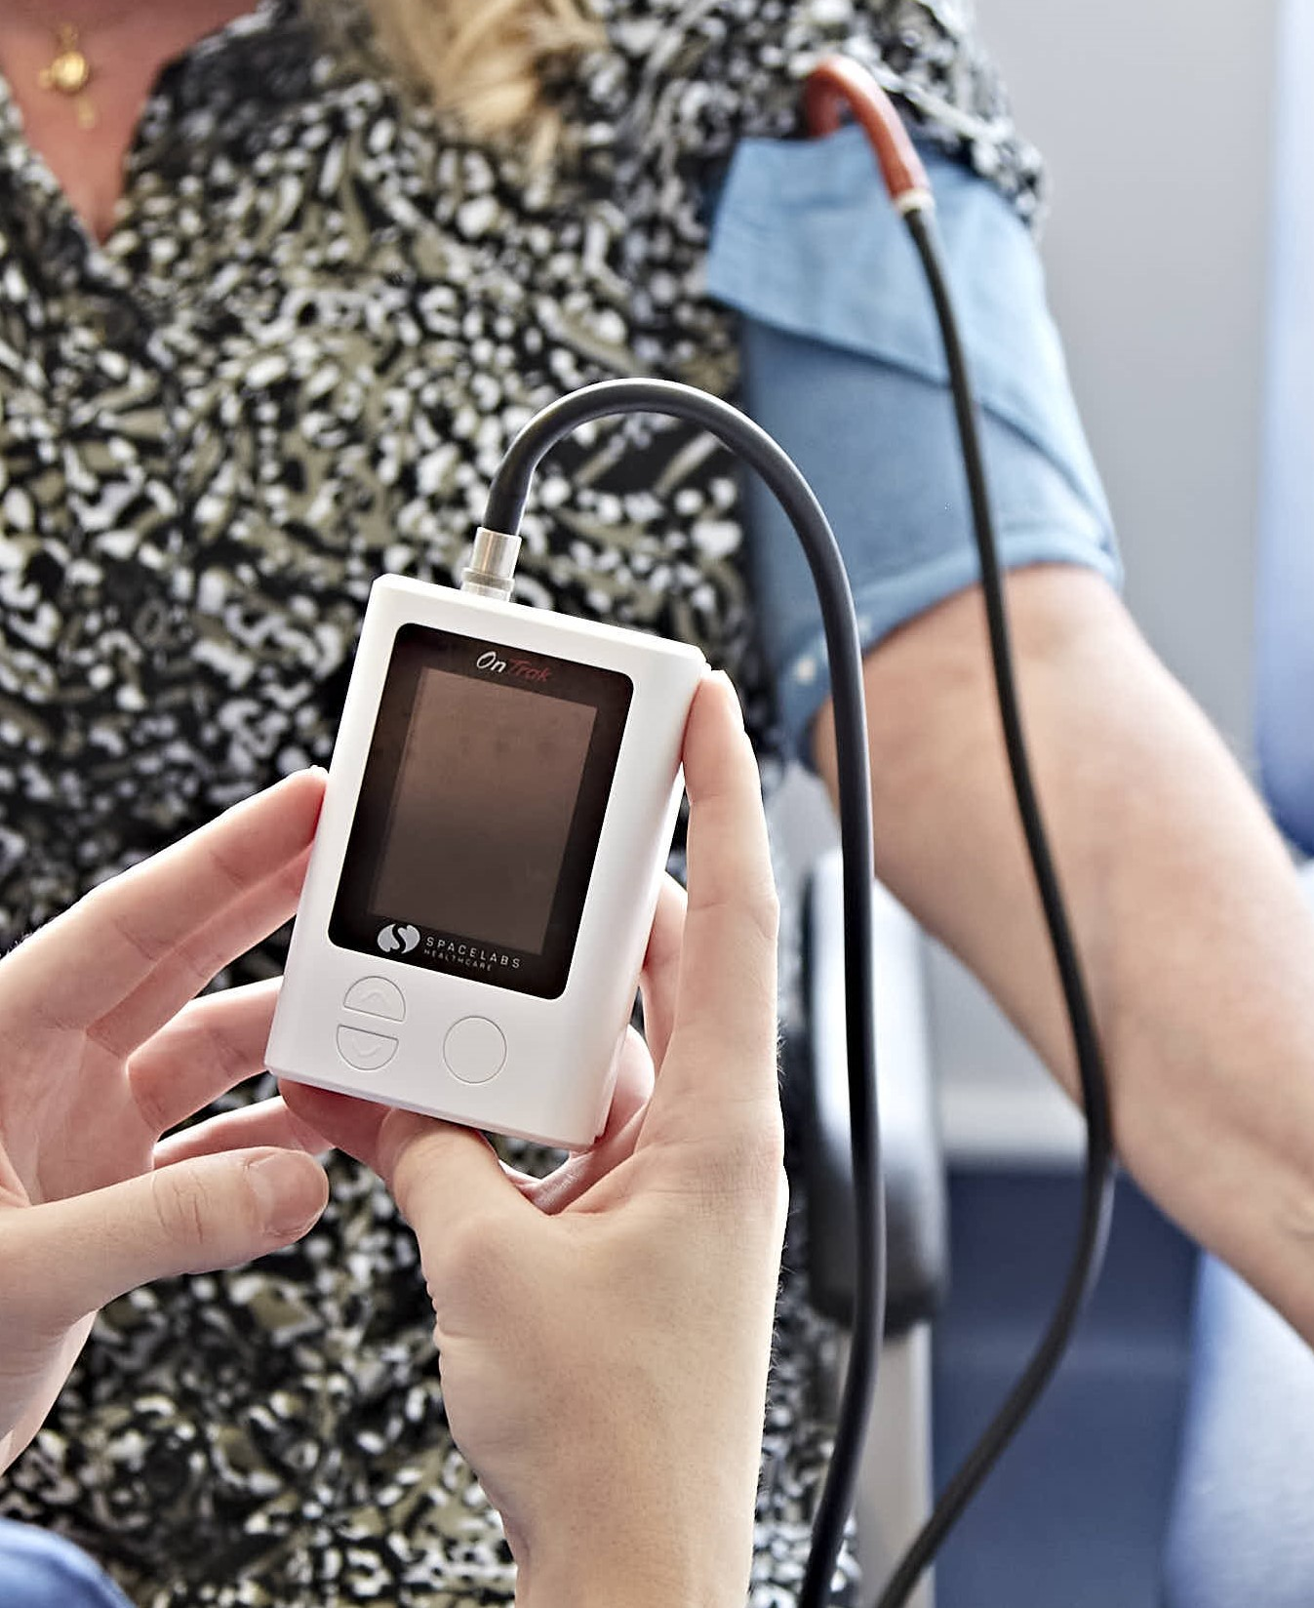
Why is an ABP Test Done?
An ABP test is performed to provide a more accurate and comprehensive picture of your blood pressure, helping diagnose conditions such as hypertension and assess how well your current treatment works.
Preparing for Your ABP Test
Here are some things you can do to prepare for your ABP test:
- Wear a loose-fitting top to accommodate the cuff.
- Ensure you wash thoroughly prior to your appointment
What Happens During an ABP Test?
During your appointment:
- A blood pressure cuff will be attached to your arm with a tube connected to a small lightweight recorder. The recorder is usually worn on your waist with a belt that we can supply, or you may wear your own.
After the monitor is fitted:
- You are free to go about your normal daily activities, except for bathing or showering, as the recorder must not get wet.
- You will wear the recorder for 24 hours, including while asleep. Please note, your sleep may be disturbed by the cuff inflating.
- You will be provided with a diary to record your daily activities and any symptoms, such as dizziness.
- The recording results will be analysed and sent to your GP.
Additional Information
- We advise that you do not drive once the monitor is fitted. If you drive for a living (e.g., Taxi, HGV, bus driver), we advise that you rearrange for a day you are off work.
- If your work shift patterns require you to work during the night, please inform us prior to attending the clinic so that we can set the monitor up correctly.
Please inform us ahead of time if you need a chaperone or prefer a healthcare
professional of a specific gender. Note that same-day requests may necessitate
rescheduling to accommodate your needs.

