72-Hour Holter Electrocardiogram (ECG)
You have been scheduled for a 72-Hour Holter Electrocardiogram (ECG) test. This is a simple and painless test that records the electrical activity of your heart, including the rate and rhythm, over a 72-hour period. The average duration of the appointment is 15-20 minutes for device fitting. After fitting, you will take the device home for the duration of the 72 hours and return it at the same time three days later (returns due on a weekend should be brought back the following Monday).

Why is a 72-Hour Holter ECG done?
A 72-Hour Holter ECG is performed to provide a detailed view of your heart’s electrical activity over an extended period. It helps healthcare professionals detect irregularities, assess heart health, and guide treatment plans.

Preparing for your 72-Hour Holter ECG
Here are some things you can do to prepare for your ECG:
- Wear a top that’s easy to take on and off.
- Ensure you wash thoroughly prior to your appointment.
- Avoid applying body lotions, oils, or talcum powder on your skin before the test.
- Some people may want to shave their chest if they are particularly hairy.
- If you have a pacemaker, please inform us and bring your pacemaker card if you have it.

What happens during a 72-Hour Holter ECG?
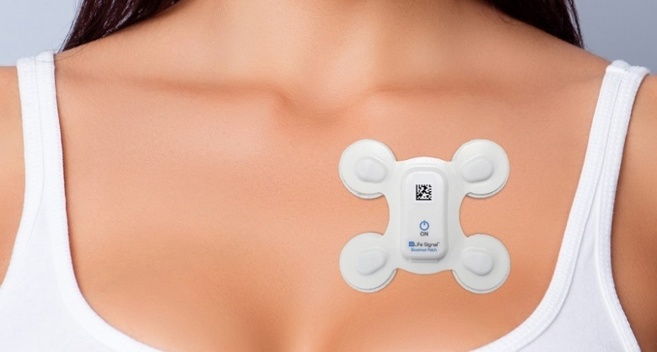
A 72-Hour Holter ECG is done by a trained healthcare professional. During the application of the Holter, you will be asked to partially undress to the waist. Some skin preparation will be performed, including gentle exfoliation, using an exfoliating tape, and cleansing with an alcohol-based wipe. A small, portable device will be attached to your chest using electrodes. This device records the electrical activity of your heart while you go about your normal daily activities.
During the 72-hour period of the Holter ECG test, it’s crucial to keep the device as dry as possible. This means you should not submerge the device i.e. swim, or bathe with the device on to prevent any damage to the device and ensure accurate results. Showering is permitted; however, you must keep your back to the shower spray and avoid completely soaking the device.
The device should not be removed at any stage during the recording period.
Important

Please ensure the monitor is returned at the agreed-upon time.

